University of California at Berkeley

College of Engineering
Department of Electrical Engineering and Computer Sciences

EECS150 J. Wawrzynek

Spring 2003

Homework #9

This homework is due on Thursday April 10th by 2pm. Homework will be accepted in the EECS150 box outside 125 Cory Hall. Late homework will be penalized by 50%. No late homework will be accepted after the solution is posted.

- From Mano: problems 5-12.

- Convert the state transition diagram of figure P5-19 (in the problem section of Mano, chapter 5) from a Mealy machine (as shown) to a Moore machine. a) Draw your state transition diagram for the Moore machine. Remember a Moore machine may need additional states. b) Write the verilog description for both the Mealy version and the Moore version of the FSM.
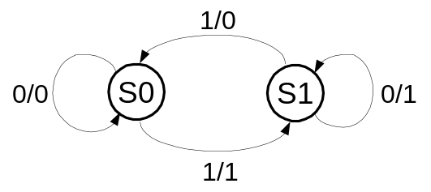
- Consider a Mealy style finite state machine with the following state transition diagram. It has a single input, IN, and a single output, OUT.

- Draw the circuit diagram for the machine:

- Draw the state transition diagram for a Moore style finite state machine with the same behavior:

c) Draw the circuit diagram for the Moore machine:

